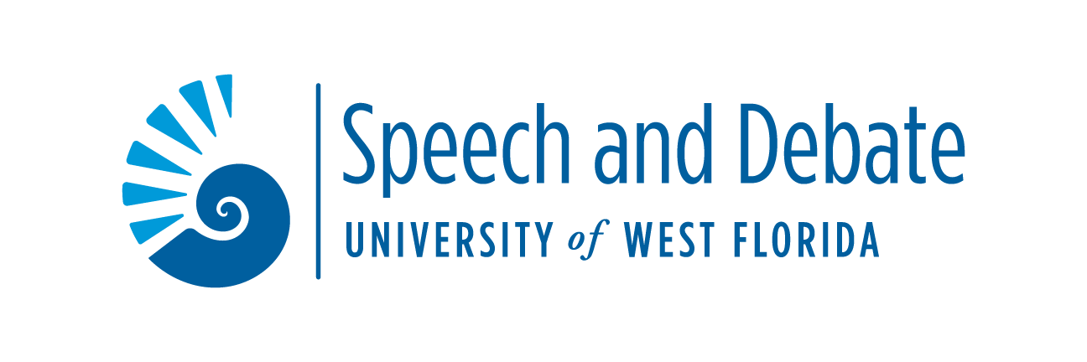

Dear Colleagues,

On behalf of UWF Speech and Debate, I’m excited to invite you to the Marks Invitational, hosted Saturday, February 14, 2026 in person on UWF’s beautiful Pensacola Campus. We will be offering a full slate of AFA-NIET individual events in a free, one-day tournament.

Since we are hosting this tournament without charging fees, we are specifically requesting that teams cover their entries (specific judge coverage details included below). We will be offering two preliminary rounds of all 11 individual events. The scheduling is designed to be as accessible and cost-effective to participating teams as possible. Our hope is to provide a no-fee tournament, and for many schools, a schedule that demands only one night hotel stays. Of course, should you and your team decide to stay another night, we highly recommend you check out the beautiful beaches and other attractions that Pensacola has to offer.

The tournament registration will be run via Speechwire, and entries will be due by 5 P.M. Central Time on Monday, February 9th. Please see tournament regulations below, and if you have any questions, please don’t hesitate to reach out at ablood@uwf.edu or 417-437-1437

Sincerely,

Adam Blood
Director of Forensics
University of West Florida.

Entry Regulations
Judging: Since we are trying to offer a tournament with no fees, we need to have slightly modified requirements for judging. One judge will cover 6 individual events, and we ask that all schools cover at least half their entry. As much as we prefer not to, we reserve the right to cut entries prior to the tournament if there is insufficient judge coverage. We are working to provide as many volunteer judges as possible from our pool of faculty, graduate students, and others willing to volunteer their time on a Saturday.

Individual Event Descriptions:
Limited Prep:
EXTEMPORANEOUS: For each round, contestants will select one of three topics on current national and international events. The contestant will have thirty minutes to prepare a speech on the topic selected. Notes are permissible but should be kept to a minimum. Maximum 7 minutes.
IMPROMPTU: Contestants will receive short excerpts dealing with items of general interest, including political, economic, and social issues. Each contestant will have a total of seven minutes to divide between preparation and speaking. Students should speak for at least three minutes. All contestants in the same section shall speak on the same topic. Maximum 7 minutes.

Platform/Public Address:
PERSUASION: A speech to convince, to move to action, or to inspire on a significant issue, delivered from memory. Maximum time is 10 minutes.
INFORMATIVE: The contestant will deliver an original factual speech on a realistic subject to fulfill a general information need of the audience. Visual aids that supplement/reinforce the message are permitted. Minimal notes are permitted. Maximum 10 minutes.
AFTER DINNER: Each contestant will present an original speech whose purpose is to make a serious point through the use of humor. The speech should reflect the development of a humorous comedic effort, not a stand-up comedy routine. The speech must be memorized. Maximum 10 minutes.
RHETORICAL CRITICISM/COMMUNICATION ANALYSIS: Contestants will deliver an original critical analysis of any significant rhetorical artifact. The speaker should limit the quotation of, paraphrasing of, or summary of the analyzed artifact to a minimum. Any legitimate critical methodology is permissible as long as it serves to open up the artifact for the audience. Minimal notes are permitted. Maximum 10 minutes.
Interpretation of Literature:
PROSE: The contestant will present a program of prose literature. Original introductory comments and transitional remarks are permitted. Programs may consist of single or multiple selections. Plays are not permitted. Manuscripts are required. Maximum 10 minutes.
POETRY: The contestant will present a program of poetic literature. Original introductory comments and transitional remarks are permitted. Programs may consist of single or multiple selections. Manuscripts are required. Maximum 10 minutes.
DRAMATIC DUO: A cutting from a play, humorous or serious, involving the portrayal of two or more characters presented by two individuals. This is not an acting event and costumes, props, etc. are not permitted. Presentation must be from manuscript and focus should be off stage. Maximum 10 minutes.
DRAMATIC INTERPRETATION: A cutting that represents one or more characters from a play or plays of literary merit. This material may be drawn from stage, screen or radio. Manuscripts are required. Maximum 10 minutes.
PROGRAMMED ORAL INTERPRETATION (POI): A program of thematically linked selections of literary merit, chosen from at least two of the three recognized genres of competitive interpretation (prose/ poetry/ drama). Manuscripts are required. Maximum 10 minutes.

Event Rules and Regulations
Our rules conform to those provided the AFA-NIET on individual events. Competitors may enter up to three events in each flight. All questions regarding violations of rules or other concerns during the tournament should be directed to Dr. Adam Blood at ablood@uwf.edu or 417-437-1437.
Pentathlon: We will be offering Pentathlon. To be eligible, a competitor must enter five events, with at least one event in each of the three genres (limited preparation, public address, interpretation of literature).
Top Novice: To be eligible for a top novice award, a student must be in the first year of competition. Novice competitors should be declared in submission of the entry and will be confirmed during tournament registration. While we will not offer separate rounds for a novice division, we will track the performance of all novice competitors to recognize the top performers in each event.
“First break” gifts: In keeping with a tradition we started at our in-person tournaments we offered pre COVID, we recognize that the first time a student advances to finals in their career is something of a milestone. Therefore, we will offer a small gift to commemorate this occasion. Any student who makes it to finals round for the first time in their collegiate forensics career will receive a congratulatory gift from the UWF Speech and Debate team.

Tournament Schedule
UWF’s Pensacola Campus is in that part of that Florida that is in the Central Standard Time Zone. Please be aware of this change as you travel to Pensacola.
8:30 AM | Extemp Draw
9:00 AM | Round 1A
10:00 AM | Extemp Draw
10:30 AM | Round 2A
11:30 AM | Lunch Break
1:00 PM | Round 1B
2:00 PM | Round 2B
3:00 PM | Extemp Finals Draw
3:30 PM | Finals A
4:30 PM | Finals B
Awards will begin ASAP after the Finals of Flight B

Flight A: Extemp, Prose, POI, Duo, CA, Persuasion
Flight B: Impromptu, Poetry, DI, Info, ADS
*Flighting may change based on specific entry sizes

